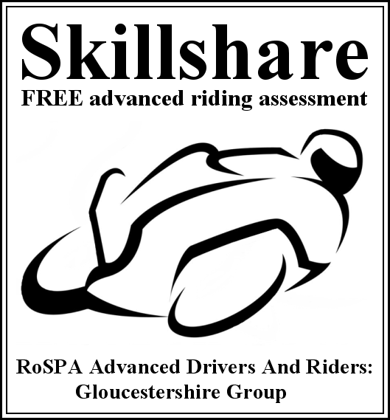

**Assessment Ride Report**

**Date: ________________ Tutor: ______________________________________________**

|  |  |  |  |  |  |  |
| --- | --- | --- | --- | --- | --- | --- |
| **Manoeuvre** | **Grade** | | | | | **Remarks** |
| ☹ 😐 ☺ | | | | |
| Moving off |  |  |  |  |  |  |
| Stopping |  |  |  |  |  |  |
| Observation |  |  |  |  |  |  |
| Planning |  |  |  |  |  |  |
| Machine control (incl slow speed) |  |  |  |  |  |  |
| Accelerating |  |  |  |  |  |  |
| Braking |  |  |  |  |  |  |
| Gears |  |  |  |  |  |  |
| Signals |  |  |  |  |  |  |
| Positioning |  |  |  |  |  |  |
| Cornering |  |  |  |  |  |  |
| Overtake / filter |  |  |  |  |  |  |
| Attitude |  |  |  |  |  |  |